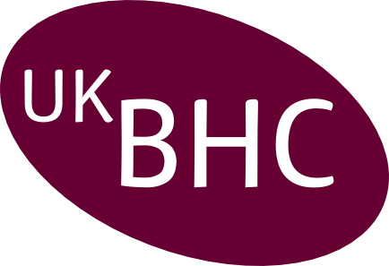
Confirmation of CPD Accreditation and Invoice of charges

Title of CPD Event
Date(s) of Event
Venue(s) of Event
Provider Organisation
Name of Organiser
Type of Organisation  tick one box |  | Healthcare Chaplaincy & NHS
Type of Organisation  tick one box |  | Educational Institution & “not-for-profit”
Type of Organisation  tick one box |  | Commercial “for profit” organisation
Charges:-
Please makes cheques payable to UKBHC and return a copy of this invoice with your cheque to: Box 105. Chaplaincy at Addenbrooke’s Hospital , Cambridge CB2 0QQ.

CPD Points Awarded

Notes
Please make cheques payable to UKBHC and return a copy of this invoice with your cheque.
Receipts will be issued by e-mail unless requested by post.

Charges are based on £75 per event as agreed by the UK Board of Healthcare Chaplaincy November 2015.

Publicity material for events accredited by UKBHC should include the UKBHC accreditation logo (see right) and the CPD points awarded. Participants should receive a certificate of attendance which should also include the logo and CPD points. Organisers must keep a register of attendance and a record of the evaluation of the event for a minimum of three years.

Revd Dr Derek J Fraser
Chair of UKBHC
Box 105, Addenbrooke's Hospital
Cambridge, CB2 2QQ
Email: djf43@cam.ac.uk
www: UKBHC.org.uk

