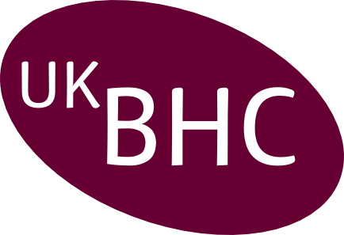
Annual Summary of
Chaplaincy CPD 2022

Name:
Designation:
Organisation:

Category | Examples | Impact of Learning on Practice | CPD hours  CPD hours work out as one per one hour of activity.
Individual:
Self-directed learning
Individual:
Professional activity
Internal:
Work-based learning
External:
Formal educational activity

Annual summary forms should be returned by 28th February 2023.

Post: Box 105, Addenbrooke’s Hospital, Cambridge CB2 0QQ,
Email: cuh.chaplaincy@nhs.net

Please retain a copy of this report for your CPD portfolio

