UKBHC Board Member profiles
Brief account of your relevant experience to date:
I have been a Chaplain at BHRUT (Barking, Havering, Redbridge University Hospitals Trust since July 2008. I have been the Lead Chaplain here since February 2015 managing both Chaplaincy and Bereavement Services.
Before becoming a Chaplain I was a qualified Youth and Community Worker for the YMCA for over 15 years, working in London, Tunbridge Wells and then eventually back to my home town of Romford.
I am also Chaplain to West Ham Football Club Academy as well as being a season ticket holder.
Any role you fulfil on the Board:
As well as being a general board member since 2014 involved in all the meetings I am responsible for the newsletter that is sent to all the registered chaplains.
What you hope to contribute to the work of UKBHC:
My passion for Chaplaincy has not faded since I started in 2008. What I hope to bring to the board is my enthusiasm, passion and vision for Chaplaincy. I believe the role of the Chaplain in our health care settings is vital and we are only touching the surface of what Chaplains can and should be involved in. I am very interested in the pastoral side of the work and believe it to be the glue that holds the clinical work together. Getting chaplaincy to a level that is recognised by government and to be recognised as the same as other health care professionals is essential and something I hope the UK board can achieve.
Photograph:
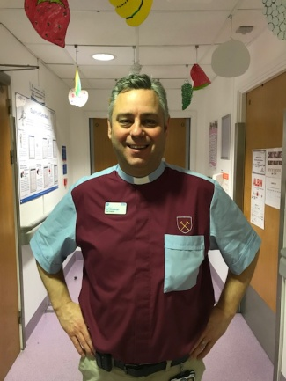

Name (including qualifications): Rev Philip Wright MA BA Hons

