UKBHC Board Member profile
Brief account of your relevant experience to date:

I count myself very fortunate to have worked alongside talented colleagues in some excellent firms, mostly Lloyd’s Insurance Brokers, based in London. Many varied and interesting experiences in my career commencing with being an Articled Clerk with a London firm of Chartered Accountants some 50+ years ago and in more recent times having Board positions as Finance Director.

On a voluntary basis I’ve served as Finance Director and Trustee of The Norfolk Hospice for 5 years and on leaving that role I was invited to be a Trustee in 2013 of an international children’s charity called Stand by Me. My trusteeship is ongoing and there is tremendous comfort in seeing how God continues to bless the work.
Any role you fulfil on the Board:

Appointed Treasurer at the Board meeting on 28th Feb 2019.

What you hope to contribute to the work of UKBHC:

UKBHC is a private company limited by guarantee and as such is regulated by Companies House. Accordingly, there are compliance matters to be adhered to and best practice disciplines to be followed in respect of financial control. I therefore look forward to using my financial and operational experience and skills to assist in the ongoing professional development of UKBHC.

Photograph:

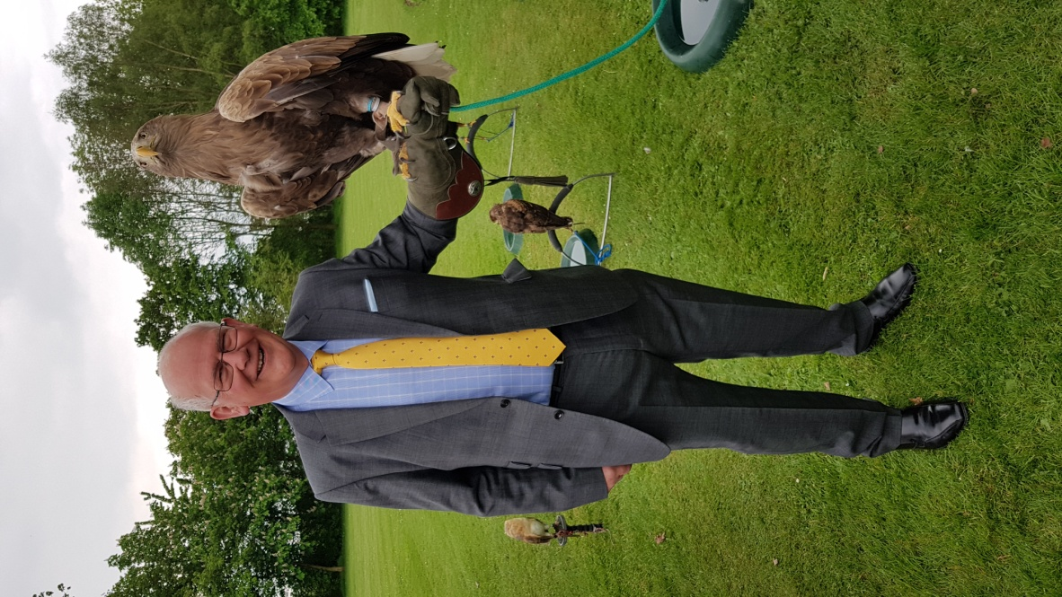

Name (including qualifications): Edward Carpenter FCA

